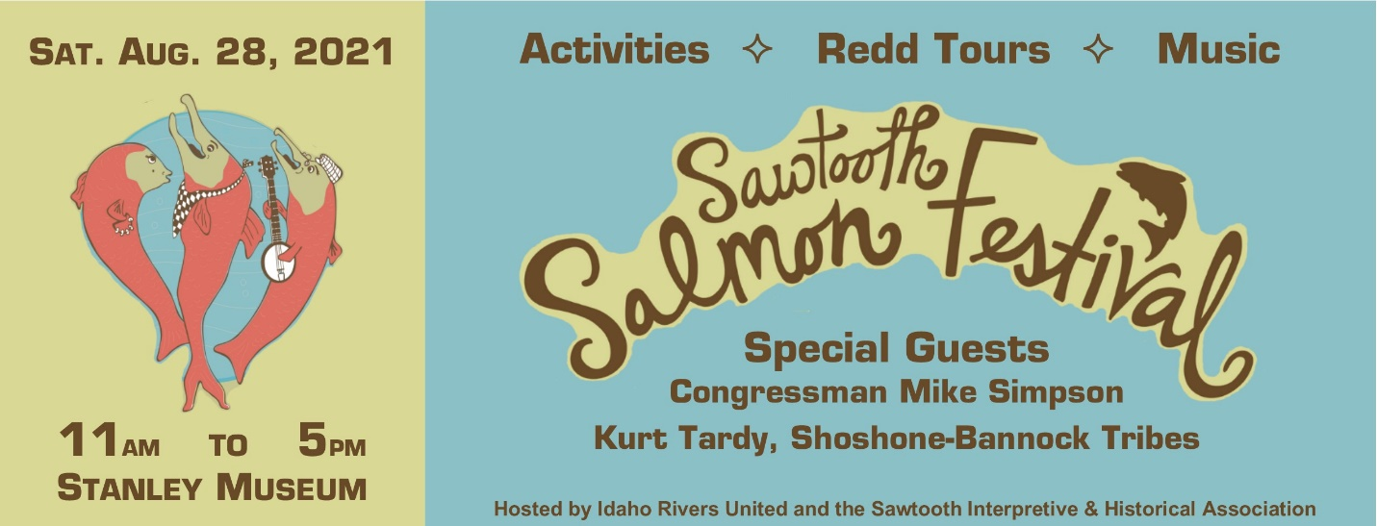

The Sawtooth Interpretive and Historical Association and Idaho Rivers United would like to thank the community for turning out to the 22nd annual Sawtooth Salmon Festival at the Stanley Museum on August 28th.

We pay special recognition to Congressman Mike Simpson and Kurt Tardy, Shoshone-Bannock Tribes Sockeye Program Manager, for joining the event this year and sharing their work. Congressman Simpson and his Chief of Staff, Lindsay Slater, were awarded the Idaho Rivers United Salmon Advocates of the Year awards at the event.

We would also like to acknowledge our sponsors for their financial support: the Stanley-Sawtooth Chamber of Commerce, Sockeye Brewing, Redfish Lake Lodge, Teton Valley Brands, Atkinson's Market, and the River Company for donating to the event. Thanks to Muzzie Braun and Dave Muscavage, and Richard Blair for providing entertainment. Finally, thanks to all the nonprofit groups and vendors who joined us and shared their salmon knowledge and expertise with the public: Idaho Conservation League, Advocates for the West, Idaho Outfitters and Guides Association, the Central Idaho Dark Sky Alliance, the Environmental Resource Center, Winter Wildlands Alliance, the Redside Foundation, the Forest Service Bear Food Safety Program and Interpretive Program, Redd River Co., and Leo Ariwite and Toni Timbana.

SIHA and IRU could not host the Sawtooth Salmon Festival without the many dedicated volunteers, board members, and staff who work tirelessly to come together to celebrate and educate the public about Idaho's iconic Chinook and Sockeye salmon. These amazing fish are symbols of hope and resilience across the West, as they labor to return to their natal waters each year despite physical barriers and a changing climate.

